**HTML Assignment**

**Element and Tag in HTML**

* **What is a tag?**

Tags are the building blocks of HTML documents and consist of angle brackets enclosing specific keywords. These tags provide instructions to web browsers on how to display the content.

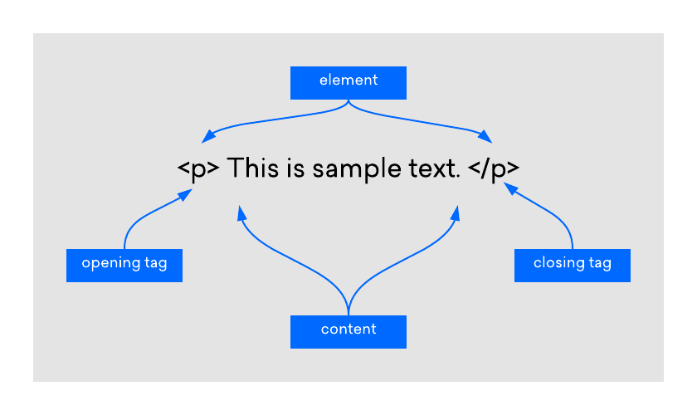

* **Types of Tags**

HTML tags can be broadly categorized into two types:

1. Paired Tags (or Container Tags)
2. Singular Tags (or Void tags)

* **What is an element ?**

HTML elements consist of a start tag,an end tag(if applicable),and content in between the tags.

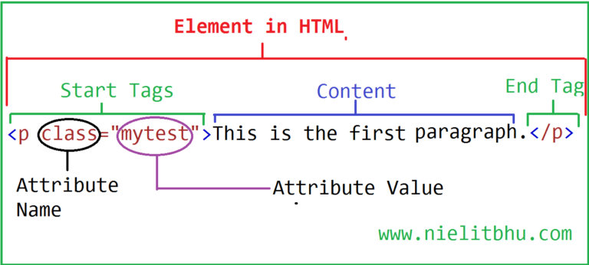

* **Some Common Tags**

1. Heading(h1,h2,h3,h4,h5,h6)
2. Paragraph(<p>)
3. <hr>tag
4. <br>tag
5. <span>

**Grouping of HTML elements**

* **Div tag**

**<div>**

**<p>This is a text</p>**

**<p>This is another text</p>**

**</div>**

**HTML comments**

* **Topics Covered**

1. Single line comment
2. Multi line comment

**Single line comment**

**<!-- this is a comment in HTML—>**

**Multi Line comments**

**<!--This is a comment in HTML with multiple lines- ->**

**Useful VS code extension**

**Topics Covered**

* Auto rename tag
* Live server
* ESLint
* Prettier
* Material icon them

**Auto Rename Tags**

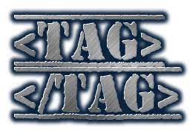

**Live Server**



**ESLint**

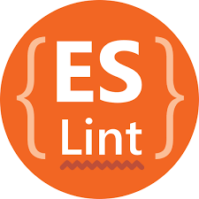

**Prettier**

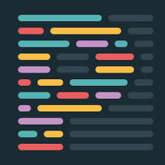

**Material Icon Theme**



**Writing a Hello World program in HTML**

**Introduction to HTML**

It stands for Hyper Text Markup language and it helps set the structure of the content in our web pages.

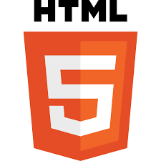

**Structure Of HTML Document**

1. <!DOCTYPE html>
2. Html lang=”en”
3. <head>
4. <tille>
5. <body>
6. <h1>
7. <p>

